STATEMENT OF COMMITMENT AND POLICY
Assisted or operative vaginal birth (AVB) refers to the use of the vacuum extractor or forceps to achieve a vaginal birth in the second stage of labor. Both methods are safe and reliable for assisting childbirth, provided that appropriate attention is paid to the indications and contraindications for the procedures.

In every case, consideration must be given to the maternal and fetal risks of using either instrument and to the risks associated with the alternative choice of cesarean section. The procedure should be undertaken only when there is a reasonable chance of success and a back up plan is in place.

The choice of instrument should suit both the clinical circumstances and the preference of the physician and the patient. The operator should have the training, experience and ability with the selected instrument to use if effectively and safely.

ROLES AND RESPONSIBILITIES

INDICATIONS:
- Atypical or abnormal FHR pattern
- Inadequate progress of labour
- Lack of effective maternal expulsive effort
- Autorotation of fetal malposition possible (**Vacuum only)
- Suboptimal attitude or position of the fetal head may be corrected (**Forceps only)

CONTRAINDICATIONS:
- Non-cephalic, face, or brow presentation
- Lack of knowledge of fetal position
- Fetal conditions (e.g. Bleeding disorder, demineralization disorder)
- Any contraindications to vaginal delivery

DEFINITIONS
Assisted or operative vaginal birth: Assisted or operative vaginal birth (AVB) refers to the use of the vacuum extractor or forceps to achieve a vaginal birth in the second stage of labor.

PROCEDURE
Vacuum Delivery: Refer to Appendix A
Forceps Deliver: Refer to Appendix B
The Society of Obstetricians and Gynaecologists of Canada (SOGC) suggests caution with sequential use of vacuum and forceps due to the potential for fetal injury. If descent is not achieved with traction on a correctly applied vacuum cup, cephalopelvic disproportion (CPD) must be suspected, and an attempt at forceps is generally not advisable. However, if a vacuum or forceps cannot be optimally applied, switching instruments prior to traction may be appropriate. If an initial vacuum traction effort fails for a technical reason, correcting the problem or switching instruments may also be appropriate.

Examination and surveillance for neonatal trauma should be performed following every vacuum or
forceps delivery, including:
  - Scalp trauma
  - Signs of cerebral irritation
  - Signs of scalp swelling, cephalohematoma, or subaponeurotic hemorrhage
  - Monitor infant feeding
Newborn assessment and head circumference should be performed at 1h, 2h, 4h, 6h, 12h, 18h, 24h then q12h x 2 days post deliver. Notifying physician of head circumference increase of 0.5cm or more.
Document use of vacuum on Partogram Nursing Progress notes and follow-up assessments in
infant’s Nurses Progress notes.

APPENDIX A:

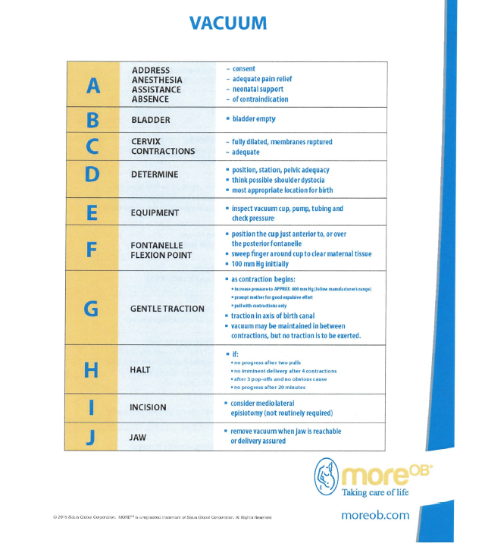

APPENDIX B:
