|  |  |  |  |  |  |  |
| --- | --- | --- | --- | --- | --- | --- |
| **STANDARD WORK – Quarterly Medication Reviews v3** | | | | | | |
| **Document Owner**: | **Clinical Manager - Pharmacy** | **Program/Service Area**: | | **Pharmacy** | **Issue Date: August 2017** |  |
| **Revision Date:** | **December 20 2019** |  | |  |  |  |
| **Approval:** | **Miriam McDonald**  Director of Pharmacy | | **Task Time (frequency): Weekly** | | |  |
| **Signature:** |  | | **Cycle Time (duration i.e. overall time of SOW): 3 hours** | | |  |

**Purpose:** *To ensure that patients admitted to Health Sciences North (HSN) with a length of stay 90 days or greater receive quarterly medications reviews overseen by a pharmacist.*

|  |  |  |  |
| --- | --- | --- | --- |
|  | Content (Task / Activity) | Time | Details / Visual Component (if applicable) |
| 1. | **Run and Print ‘Patient LOS over 90 Days’ list** | **2 min** | 1. Enter MediTech 2. Click Admissions🡪 Custom Report 🡪 SRH🡪 Registration Reports🡪Patient LOS over # Days🡪Enter “90” in search field 🡪OK |
| 2. | **Consolidate List** | **5 min** | 1. Compare current list with the list of the previous day to determine  # of new patients # of discharged patients 2. Record statistics in Quarterly Medication Review excel |
| 3. | **Select a Patient to Review** | **1 min** | Select the patient with the longest days overdue. Notify unit pharmacist at the beginning of the week that patient case will be reviewed. |
| 4. | **Complete Chart Review** | **120 min** | 1. Review past medical history through EMR, front of chart, and MD notes if needed. 2. Review old CMARs from past month to determine PRN usage and suggest D/C of medications which have not been used in previous month (using clinical judgement) 3. Read recent nursing notes 4. Review recent orders 5. Review medications 6. Review relevant lab work 7. Speak with nursing staff and patient regarding quality of life indicators |
| 5. | **Review Patient Case and Interventions with Pharmacist** | **15 min** | Review patient work up with unit pharmacist. Discuss drug therapy problems and recommendations. Follow up as required. |
| 6. | **Fill out Intervention Template** | **10 min** | 1. Log into MediTech 2. Go to Pharmacist Desktop 3. Go to patient profile 4. Press Intervention 5. Enter information under intervention as indicated in Figure 1.    1. Individual who completed medication review will enter their own name under staff member. 6. Press the” Drug” tab at the top of the intervention and delete all keywords 7. Under the “Text” tab, press the F5 key and enter “SRMER” to autofill the template. 8. Fill in template information. 9. Record month and day completed at the top of the intervention template and add initials at the end. |
| 7. | **Fill out Pharmacy Communication Form (PCR)** | **5 min** | Complete PCR detailing recommendations. “Quarterly Medication Review Complete” must be written at the top of the PCR” followed by any recommendations. Include patient unit at top of PCR (e.g. 4N). |
| 8. | **Follow-up/Monitoring** | **ongoing** | Periodically run intervention list on MediTech to identify all patients requiring follow up.   1. Log into MediTech 2. Go to Pharmacist Desktop 3. Go to patient profile 4. Press Intervention 5. Press Patient 6. Click List 7. Under General, select appropriate time frame (start of co-op to today’s date) 8. Under Filters 1, select MER as Intervention Type 9. Select A (Active) as Status 10. Under Filters 2, select PHS (Pharmacy Student) as Staff Type 11. Select your User Name 12. Press OK   Follow up on any requested lab work or other recommendations that require follow-up.  Write follow-up plan and date of next 90 day review under the “follow-up” heading of the template.  Once follow-up is complete, change MER intervention status to C (complete). |

**Expected Outcome:** 100% capture of Quarterly Medication reviews

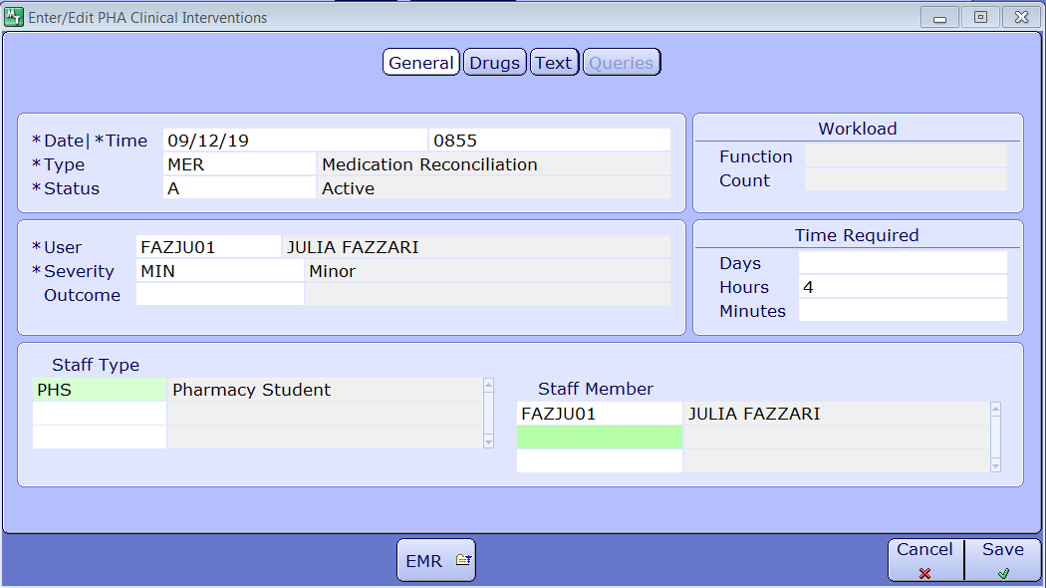**Figure 1: Intervention information NOTE: please use own username for “user” and “staff member”**

**Work Process/Tips:**

1. Fill in the 90-day review worksheet using the information on MEDITECH
   1. Under “Patient Profile,” click on “Instructions” to order the meds according to SCH or PRN
   2. EMR → Medications → All
      1. Write the start date of the meds
      2. Click on “Generic name” to order them in alphabetical order
      3. Some meds will be discontinued and restarted on the same day → have to look for when it was 1st started and used non-stop by the patient.

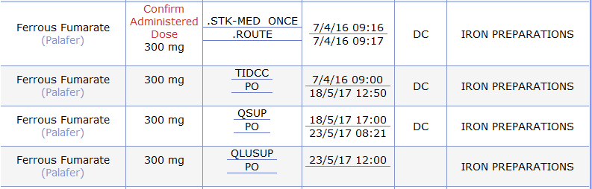

Note: Ferrous fumarate actually started on Apr 7 and not May 5. This is why you look under the “All” tab and not the “Active” tab

* 1. For weight: EMR → Summary → Indicator to see when it was last recorded
  2. Other reports → All
     1. To get previous patient history for this admission
  3. Other Visit → View All Visits
     1. Get lab data from previous admissions
     2. Get reports from previous admissions

1. Go to patient chart:
   1. Read “MD Notes”
   2. Under “Medication” look at any prn uses of meds
   3. Look at Nurses notes for more information on patient
2. Talk to patient if they can give an accurate history about themselves or their condition (may not always be an option if the patient has cognitive impairments)
3. Talk to the nurse to see if they have any concerns or to get more information on patient status, behaviour, bowel/bladder, etc