PURPOSE:
The goal of intrapartum fetal health surveillance (FHS) is to detect potential fetal decompensation and to allow timely and effective intervention to prevent perinatal/neonatal morbidity or mortality. Fetal Heart Rate (FHR) characteristics are determined by assessing the FHR pattern in association with the uterine activity over time to develop a comprehensive clinical picture. Intermittent auscultation (IA) and electronic fetal monitoring (EFM) are screening tests for intrapartum fetal well-being; decisions regarding which method to use are based on maternal-fetal risk of adverse events and informed decision making by the patient.
When communicating Fetal Health Surveillance with colleagues and documenting fetal health surveillance, current fetal health surveillance terminology should be used to describe the uterine activity, fetal heart rate, and the classification.

POLICY:
This policy is to apply to members of intrapartum care teams, including but not limited to obstetricians, family physicians, midwives and nurses and their learners. Recommendation to implement formal education requirements in fetal health surveillance for all providers of intrapartum obstetrical care (physicians, nurses, midwives) with review every 2 years.
Intermittent Auscultation
- Intermittent Auscultation (IA) is the recommended method of intrapartum fetal surveillance for healthy women between 37 0/7 and 41 3/7 weeks gestation in spontaneous labour, in the absence of risk factors for adverse perinatal and neonatal outcomes. See Appendix 1: Antenatal and intrapartum conditions associated with increased risk of adverse fetal outcome where intrapartum electronic fetal surveillance may be beneficial.
- Intermittent Auscultation (IA) may be used for women who are 41 4/7 to 42 0/7 with a documented normal NST and normal AFV in the absences of risk factors for adverse perinatal and neonatal outcomes.
- Intermittent Auscultation is to be done after uterine activity is assessed by palpation and the fetal lie determined; place the fetoscope or the Doppler transducer over the back of the fetus. While the maternal pulse is being assessed, the FHR is auscultated between uterine contractions to establish the FHR baseline.
- IA is to be done immediately after and between contractions for 30 to 60 seconds.
- The presence of spontaneous accelerations is a normal finding, it is not required in order for the fetal health surveillance assessment to be classified as normal.
- While doing IA if an abnormal fetal heart rate is found, re-position the patient and listen to the FHR after the next contraction OR by immediately initiating EFM. If decelerations persist after the next contraction, initiate EFM if not already initiated to confirm the fetal heart rate pattern. Intrauterine resuscitation should be initiated as required.,
- If EFM was initiated for abnormal IA, you can discontinue monitoring if the tracing is normal and you have reviewed the overall clinical picture and have determined there are no maternal risk factors present; the recommended minimum period for EFM tracing is 20 Minutes.
- The use of IA is appropriate with initiation and continued use of epidural anaesthesia provided there are no maternal-fetal risk factors for adverse perinatal outcomes and/or obstetrical considerations, frequency of assessment is increased (ie. EFM 30 mins post insertion of epidural), maternal vital signs are stable post epidural, patient controlled epidural analgesia (PCEA) is used.
Electronic Fetal Monitoring

- Ensure the electronic fetal monitor has the correct date and time displayed. Facilities should adopt a tracing paper speed of 3cm/min for electronic fetal monitoring to facilitate national consistency.
- Practitioners should use standard terminology when describing fetal heart rate patterns. (See SOGC Classification of Intrapartum EFM tracings). The terms normal, atypical and abnormal are used to classify electronic fetal monitoring. (See Appendix 3)
- When atypical or abnormal findings of the fetal heart rate are found the nurse or midwife must perform intrauterine resuscitation measures.
- Digital fetal scalp stimulation is recommended in response to atypical fetal heart tracings.
- The presence of spontaneous accelerations is a normal finding, it is not required in order for the EFM tracing to be classified as normal. Consider accelerations in the presence of abnormal FHR tracings as part of the overall clinical picture; however, the accelerations do not change the tracing classification.
- Labour inductions/augmentations with oxytocin require continuous external fetal monitoring. When a normal tracing is identified, it may be appropriate to interrupt the electronic fetal monitoring tracing for up to 30 minutes to facilitate periods of ambulation, hydrotherapy or position change providing that a) the maternal-fetal condition is stable and b) if oxytocin is being administered, the infusion rate is not increased.
- EFM should be used when combined spinal epidural analgesia (CSE) is used because CSE is associated with a higher risk of an atypical or abnormal fetal heart pattern than with the use of epidural alone.
- Continuous Electronic Fetal Monitoring (EFM) should be the mode for monitoring for the risk factors identified in Appendix 1.
Frequency of Assessments

 | IA FHS | EFM FHS | MHRª
Latent Phase of labour if admitted to birthing area or individualized based on maternal fetal status if in triage. | Q 1 hour | Q 1 hour | On admission and when determining baseline FHR
Active first and passive second stage | Q15-30 mins | Q 15 mins | Q 4 hours with intact membranes OR  Q 2 hours with ruptured membranes
Active second stage | Q 5 minutes | Q 15 minutes IF continuous tracing and caregiver continuously present | Q 15-30 mins^{b}
ª Additionally done any time there is uncertainty between the MHR and FHR and if intrauterine resuscitation is initiated.
^{b} consider a continuous tracing using tocydynamometer if available and document every 15 minutes.

Documentation
- Standard documentation practices are to be encouraged among all caregivers. Documentation may consist of narrative notes or the use of comprehensive flow sheets detailing the periodic assessments. The following information should be included.

Intermittent Auscultation, what is assessed when using IA
- Uterine activity characteristics obtained by palpation:
- Frequency- number of contractions in a 10 minute period average over 30 mins
- Duration
- Intensity
- Relaxation between contractions
- FHR data:
- Baseline FHR including determination of MHR
- Rhythm
- Accelerations
- Decelerations
- Classification of the IA (Appendix 2)
- Interpretation
- Maternal and fetal responses to interventions.
- Communication with the MRP when the findings are abnormal.

What cannot be assessed when using IA: baseline variability, type of deceleration

Electronic Fetal Monitoring
- The indication for initiating EFM must be documented.
- Monitoring strips must have the patient sticker, date and time charted on the graph paper:
- Uterine activity characteristics are obtained by external/internal tocodynamometer and/or palpation:
- Frequency- number of contractions in a 10 minute period average over 30 mins
- Duration
- Intensity
- Relaxation between contractions
- FHR assessment: baseline rate, baseline variability, accelerations and decelerations
- Classification of the tracing as normal, atypical or abnormal
- Interpretation of the clinical picture
- Maternal and fetal responses to interventions

Intrauterine Resuscitation: goal is to improve uterine blood flow, umbilical circulation, and maternal-fetal oxygenation. Actions may include the following:

- Remove vaginal PGE2/Stop or decrease oxytocin
- Change maternal position to left or right lateral
- Check maternal vital signs, including differentiation of MHR from FHR
- Ask woman to modify or pause pushing efforts in the active second stage of labour
- Improve maternal hydration, with an intravenous fluid bolus, only if indicated (ie. Maternal hypovolemia and/or hypotension); be aware of maternal fluid balance.
- Perform vaginal examination to rule out cord prolapse and assess progress
- Consider tocolysis in the presence of tachysystole with atypical or abnormal tracing
- Provide supportive care to reduce maternal anxiety (to lessen catecholomine impact)
- Consider oxygen by mask only when maternal hypoxia and/or hypovolemia is suspected/confirmed

** Oxygen is reserved for maternal resuscitation in the presence of maternal hypoxia or hypovolemia, NOT for fetal resuscitation.

**Fetal scalp stimulation is not a resuscitative intervention, it should be avoided during a FHR deceleration, and applying substantial pressure may produce a vagal response and result in a deceleration.

Types of Decelerations
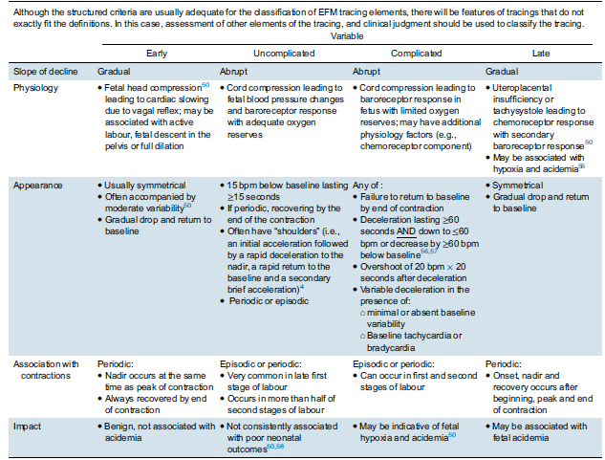
Society of Obstetricians & Gynecologists of Canada, Clinical Practice Guidelines revised March 2020: Fetal Health Surveillance: Intrapartum Consensus Guideline.

Internal Fetal Monitoring:

Internal fetal monitoring is performed with a spiral electrode inserted through the maternal vagina and cervix and attached to the fetal scalp or other presenting part. Internal monitoring may be indicated when the external tracing is inadequate for accurate interpretation.

RESPONSIBILITY:
The Physician/Midwife is responsible for inserting and attaching the electrode to the presenting part of the fetus, and the RN/RM is responsible for monitoring the fetal heart rate.

EQUIPMENT:
1. Monitor, leg electrode and connector cable.
2. Spiral electrode.
3. Sterile gloves.
4. Lubricant.
5. Amniotome (if membranes not ruptured).

METHOD:
- Explain procedure and equipment to patient to allay patient’s concerns regarding personal discomfort and infant safety.
- Have patient assume a low semi-Fowler’s position with knees flexed to allow easier access to the cervix.
- Continue external fetal monitoring until the internal scalp electrode is placed.
- Attach leg cable to patient using a leg electrode.
- Physician will do vaginal examination and place scalp electrode on fetal head.
- Attach the electrode wires to the leg cable.
- Plug leg cable into monitor outlet.
- Unplug external transducer.
- Evaluate fetal heart rate and rhythm. Listen for audible beep with each QRS complex. Observe digital display.
- Record procedure on labour and delivery flow sheet and progress notes.

APPENDICES:
Appendix 1: Antenatal and intrapartum conditions associated with increased risk of adverse fetal outcome where intrapartum electronic fetal surveillance may be beneficial.
Appendix 2: Classification of IA Findings
Appendix 3: Classification of Intrapartum EFM Findings
Appendix 4: Response to IA and EFM tracing Classifications

REFERENCES:

Champlain Maternal Newborn Regional Program. (2011) Intermittent Auscultation of the Fetal Heart Rate.

Enkin, M., Keirse, M., Neilson, J., Crowther, C., Duley, L., Hodnett, E. & Hofmeyr, J.
(2000) A guide to effective care in pregnancy and childbirth. 3rd Edition. Oxford University Press, New York.

Feinstein, N.F., Sprague, A. & Trepanier, M.J. (2000) Fetal heart rate auscultation. AWHONN.

Liston, R., Sawchuck, D.& Young, D. (2007) Fetal Health Surveillance: Antepartum & Intrapartum Consensus Guideline SOGC Clinical Practice Guideline; Vol 29, No.9.

Perinatal Death Review – Feb. 2011

Perinatal Partnership Program of Eastern & Southwestern Ontario (2008). Electronic Fetal Monitoring Document.

Perinatal Partnership Program of Eastern & Southwestern Ontario (2009). Non-Stress Test Document

Sixth Annual Report of the Chief Coroner of Ontario December 1999.

SOGC Clinical Practice Guidelines (2020). No. 396-Fetal Health Surveillance: Intrapartum Consensus Guideline

Sprague, A. (1995). Auscultation of FHR – Decision Tree, PPPESO & Ottawa Hospital Maternal Newborn Program.

Tucker, S., Miller, L., & Miller, D. (2009) Fetal Monitoring: A Mulitdisciplinary Approach. Mosby: St. Louis: Missour

Appendix 1: Antenatal and intrapartum conditions associated with increased risk of adverse fetal outcome where intrapartum electronic fetal surveillance may be beneficial.
*Note: List is not exhaustive and should not replace clinical judgement

Antenatal
Maternal | - Hypertensive disorders of pregnancy  - Pre-existing diabetes mellitus/Gestational diabetes  - Antepartum hemorrhage  - Maternal medical disease: cardiac, anemia, hyperthyroidism, vascular disease and renal disease.  - Following Trauma or MVA (EFM recommended for min 4-6 hours)  - Morbid obesity BMI > 40
Fetal | - Intrauterine growth restriction  - Abnormal umbilical artery Doppler velocimetry  - Single umbilical artery  - Oligohydramnios  - Polyhydramnios  - Abnormal BPP or NST  - Significant fetal abnormality  - Isoimmunization  - Multiple pregnancy  - Velamentous Cord Insertion
Intrapartum
Maternal | - Vaginal bleeding in labour  - Intrauterine infection/chorioamnionitis  - Previous Caesarean Section/TOLAC  - Prolonged ROM > 24 hours at term  - Oxytocin induction or augmentation  - Labour Dystocia  - Tachysystole  - Combined spinal-epidural analgesia (CSE)  - Difficulties in reliably determining UA and/or FHR with IA  - Post-term pregnancy (>42 weeks)
Fetal | - Abnormal FHR on auscultation  - Prematurity (<37 0/7 weeks)  - Meconium staining of the amniotic fluid  - Breech presentation  - FHR arrhythmia
Adapted from SOGC Fetal Health Surveillance: Antepartum and intrapartum Consensus Guideline revised 2020
*TOLAC- Trial of Labour after Caesarean

APPENDIX 2: Classification of IA findings
NORMAL | ABNORMAL
Normal baseline heart rate: 110-160 bpm  Baseline rate (110-160 bpm)  The presence of increases in FHR is not required  Absence of decreases in the FHR | Tachysystole  Abnormal baseline heart rate.  - Tachycardia >160 bpm  - Bradycardia < 110bpm  - Changing FHR baseline (increasing or decreasing over time)  Presence of decelerations  Arrythmia

Appendix 3: SOGC Classification of Intrapartum EFM tracings.
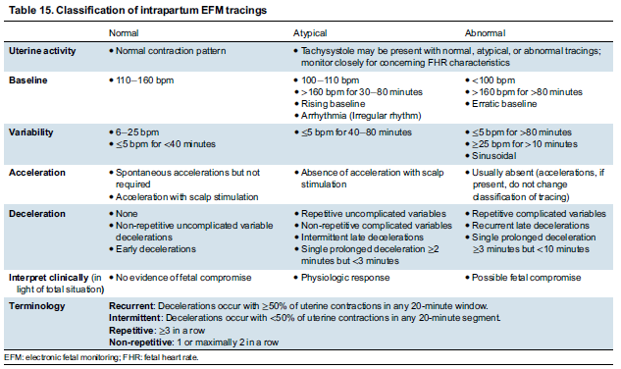
Society of Obstetricians & Gynecologists of Canada, Clinical Practice Guidelines revised March 2020: Fetal Health Surveillance: Intrapartum Consensus Guideline.

APPENDIX 4: Response to IA and EFM tracing Classifications
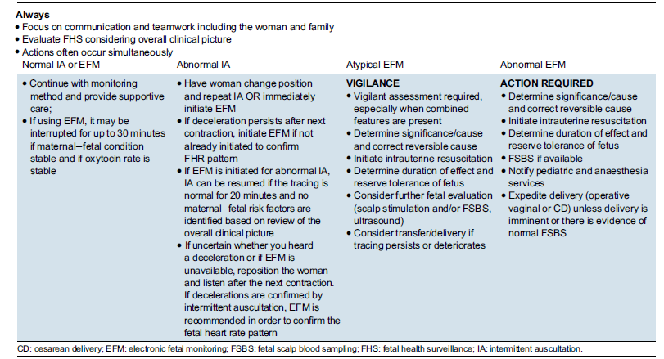
Society of Obstetricians & Gynecologists of Canada, Clinical Practice Guidelines revised March 2020: Fetal Health Surveillance: Intrapartum Consensus Guideline.

