|  |  |  |
| --- | --- | --- |
|  | Allergy Management and Documentation – Policy and Procedures | |
| Manual: Clinical | Document No.: |
| Section: Interdisciplinary Patient Services | Original Date:  27SEP2011 |
| Document Sponsor/Owner Group: Interprofessional Practice | Revision Date(s):  22SEP2020  16NOV2021 |
| Approved by: Nursing Professional Practice, Interprofessional Collaboration Committee, Pharmacy and Therapeutics Committee, Medical Advisory Committee | Review Date:  DDMONYYYY |
| Cross Reference to: Drug Allergy and Adverse Reaction Policy and Procedures; Blood Product Ordering Release and Administration Policy and Procedure, Interpretation and Translation Services Policy and Procedure; Transfer of Accountability Policy and Procedures | |
| Document Applies to: All Lakeridge Health (LH) Clinical Staff | |
| A printed copy of this document may not reflect the current, electronic version on Lakeridge Health’s Intranet, OASIS, Any copies of this document appearing in paper form should ALWAYS be checked against the electronic version prior to use. | | |

# Introduction

Lakeridge Health (LH) is committed to providing safe care to patients with allergies and/or adverse reactions to medication, food, latex, environmental or seasonal allergens, contrast medium, adhesive and skin care products, blood/blood products, vaccines, dialyzer or other.

Managing suspected and/or confirmed allergies requires a multi-disciplinary approach to ensure minimization of risk. Any member of the healthcare team involved in the patient’s care has a responsibility to be aware of the patient’s suspected or confirmed allergies.

This policy outlines the management of allergy information including the assessment, documentation, communication off allergies, adverse reactions and the level of reactions for all patients.

In addition, this policy will outline:

* Clear guidance for staff on individual responsibility to communicate and manage allergies for any patient at LH
* Procedures for allergy management
* The appropriate training and education on allergy assessment and management

For reactions to medication refer to the *Drug Allergy and Adverse Reaction – Policy and Procedure.*

# Policy

Patients cared for at LH will have their allergies and/or adverse reaction(s) reviewed by a Regulated Health Care Provider (RHCP), the Most Responsible Provider (MRP), or delegate, as determined by the program (e.g., registration clerk), to determine the:

* allergy
* adverse reaction
* severity

Allergies and/or adverse reaction status will be assessed, communicated and documented by the RHCP before (but not limited to) the following:

* Transitions in care (e.g. admission, transfer or discharge)
* When new allergies are reported by the patient or substitute decision maker (SDM)
* Entry of providers’ orders in the patient’s electronic health record (EHR) (e.g. dietary orders)
* Administration of medication(s)
* Prescribing medication(s)
* Verification of medication orders
* Any procedure where exposure to an allergen could occur (e.g. insertion of a Foley catheter, Computed Tomography (CT) Scan)
* Use of an equipment or supplies (e.g. gloves)
* An outpatient appointment
* An Emergency Department visit
* As determined by the RHCP

# Assessment

The initial allergen assessment will occur at the first interaction with a RHCP or designate during the patient’s hospital visit.

The RHCP or their designate will conduct an allergen assessment by asking the patient and/or SDM the following questions:

* Does the patient have any known allergies or have they experienced any adverse reactions?
* If the answer is yes, the relevant allergen or agent will be added to the patient's record.
* What was the specific reaction experienced? (e.g. anaphylaxis, hives, etc.)
* Based on the selected reaction type, a severity level may be automatically generated during documentation.
* What type of reaction occurred? (e.g. allergy, contraindication, intolerance, or unspecified).
* Allergen information may also be obtained from additional sources such as:
* Patients’ EHR; internal and external to LH
* MRP documentation
* Transfer record from another institution
* Community pharmacy
* RHCPs involved in medication administration will review drug therapy to determine if changes in therapy are indicated.
* RHCPs involved in administering, ordering or suggesting diet adjustments will ensure a review of patient allergies is conducted.

In the event that management of anaphylaxis is required due to a life-threatening or serious emergency, refer to Appendix A.

**Identification**

For areas that utilize identification bands, allergy information will not be displayed on printed armbands. Instead, a separate allergy armband will be placed on the patient’s wrist by a RHCP or a member of the registration team, which will be indicated by a red color. The allergy armband will not contain any allergy information; therefore, RHCPs will need to access the EHR for further details.

For areas that do not utilize identification bands, all patients’ allergies/adverse reactions will be reviewed and verified verbally by the RHCP or the registration team at the beginning of the visit, as well as throughout the visit applicable (e.g. prior to providing a treatment).

**Latex Allergy Management**

When caring for a patient with a known latex allergy, latex-free supplies must always be utilized.

All latex-containing products must be removed from the patient's room or care area to prevent accidental exposure.

Before taking any equipment or supplies into the patient's room or care area, read all packaging and labels to verify they are latex-free.

All contents within any pre-packaged procedure kits must be reviewed for an indication of presence of latex. Often this may be noted on the outer packaging, (i.e. “rubber stopper” (not latex free) or “latex- free”).

# Reactions due to exposure and/or sensitivity to latex refer to Appendix B.

# For patients with a documented or reported latex allergy who require Parenteral Drug Administration, please refer to the information provided in the Appendix C.

**Documentation**

* Allergies, adverse reactions and severity (if known) will be documented in the patient’s EHR at the time an assessment is conducted.
* Allergy documentation is part of required documentation, and a best practice advisory (BPA) will notify the RHCP to ensure completion of the documentation.
* If there are no known allergens, 'No Known Allergies' will be documented in the EHR. In cases where an allergen assessment cannot be completed, resulting in unavailable information for documentation in the EHR, the RHCP will be notified with a Best Practice Advisory (BPA) until the assessment is completed. The RHCP must make every effort to obtain information regarding the patient's allergies (e.g. consulting the SDM)

**Editing or Deletion of Allergies within the Patients’ EHR**

The RHCP that becomes aware of change(s) in allergen details will edit symptoms, severity and/or delete allergens. Document the reason for the deletion of the allergen in the patients’ EHR, by selecting the appropriate rationale:

* Erroneous entry
* No longer clinically significant
* Comment field is available for further detail

**Communication**

Information about allergies, adverse reactions and level of reaction will be communicated to members of the healthcare team in the EHR record and communicated as per the *Transfer of Accountability (TOA) – Policy and Procedure*.

In the event of an allergic or adverse reaction to a drug, refer to the *Drug Allergy and Adverse Reaction – Policy and Procedure*.

In the event of an allergic or adverse reaction to a blood product, refer to the *Blood Product Ordering, Release and Administration – Policy and Procedure*.

**Education with the Patient and their Essential Partners-in-Care for Newly Identified Allergy**

* Determine the patient and/or their essential partner-in-care’s (EPC) preferred language for communicating with the healthcare team. If their preferred language is not English or if they require American Sign Language (ASL), an interpreter should be arranged. See the *Interpretation and Translation Services – Policy and Procedure* for more information.
* Clearly explain the following to the patient and their EPC in simple terms:
* Severe allergies can be life-threatening, with symptoms such as hives, trouble breathing, and low blood pressure.
* Anaphylactic shock can happen and may be deadly without quick treatment with an adrenaline injection (also know as epinephrine), even if the patient has not had a reaction to the allergen before.
* The patient should always wear a Medic Alert bracelet, which is worn to alert emergency responders about important medical information.
* The patient should be comfortable with using self-administered epinephrine as prescribed.
* After reviewing this information with the patient, ask them to explain their understanding and actions in their own words. If they are not able to, provide additional information in simple terms and reassess their understanding again. Document the use of the teach-back method and the patient's response.

**Definitions:**

**Adverse reaction:** An undesirable effect to a substance and/or health product. Health products include drugs, medical devices and natural health products. Drugs include prescription and non-prescription pharmaceuticals, biologically derived products such as vaccines, serums, and blood derived products, cells, tissues and organs, disinfectants and radiopharmaceuticals.

**Allergen:** Any substance capable of causing an allergic or adverse response such as:

* Medication
* Food
* Latex
* Environmental or seasonal
* Contrast medium
* Adhesives and skin care products
* Blood/blood products
* Vaccines
* Dialyzer

**Allergy:** An immune response/hypersensitivity following exposure with an allergen.

**Anaphylaxis:** A severe and rapid allergic reaction that can be life-threatening, characterized by symptoms such as difficulty breathing, swelling, hives, and a drop in blood pressure, requiring immediate medical intervention.

**Food Allergy**: Food allergies are sensitivities caused by a reaction of the body’s immune system to specific proteins in a food.

**No Known Allergies (NKA)**: Documentation that reflects that the patient has no known adverse reactions/hypersensitivities to an allergen.

**Transition Points:** The transfer of a patient between different care areas. Examples of transition points include admission, discharge, or transfer from one area of care to another.

**Unobtainable Allergies**: Documentation that reflects the inability to assess a patient’s allergy status. Documentation in EHR is provided as “Unable to Assess” and the reason.

# Procedure

**Identification, Documentation, and Communication**

**The primary nurse (including the triage nurse in the Emergency Department) or designate will**:

1. Ensure that an allergen assessment is completed.
2. Review and document any allergies, adverse reactions and level of reaction (if known)
   * If there are discrepancies, update allergen information in the patient’s EHR.
3. Apply a red allergy armband unless not applicable to clinical area.

**The MRP will:**

1. Review and document allergies prior to the ordering of medication(s), ordering and/or performing procedures and/or treatments (e.g., diagnostic imaging).
2. Review for discrepancies and update allergen information in the patient’s EHR.

**Pharmacist will:**

1. Review allergy status during verification of orders.
2. Update allergen documentation according to the patient/Substitute Decision Makers (SDM) interview.
3. Review any allergens to determine if changes in therapy are indicated and communicate with the MRP as required.

**Pharmacy Technician will:**

1. Update allergen documentation, as required.
2. Communicate any changes to the most responsible RHCP (e.g., nurse, pharmacist).

**Registered Dietitian (RD):**

1. The routine assessment by the RD does not always include an allergen assessment. If a referral for the assessment of food allergens is placed, the RD will:
   1. Review documented allergens prior to the patient consult.
   2. Assess for any food allergen during diet history.
   3. Document any identified food allergens in the patient’s EHR and communicate with MRP, as required, if changes in therapy are indicated.
   4. Assess the patient’s need for health teaching/diet counselling related to the food allergy.

# Reaction due to exposure and/or sensitivity

**The nurse will:**

* 1. Assess the patient’s signs and symptoms.
  2. Contact the MRP and RD.
  3. Implement the appropriate treatment as ordered by the MRP.
  4. Monitor the patient as directed by the MRP.
  5. Document findings in the patient’s EHR.
  6. Update the allergy documentation if needed.
  7. Enter an incident report if the allergy was unknown to the patient, or if the allergy was a known allergy but the patient was exposed to the allergen in error.

For reactions due to a allergen exposure refer to Appendix B.

In the event that management of anaphylaxis is required due to a life-threatening or serious emergency, refer to Appendix A.

# The MRP will:

1. Assess the patient’s sign and symptoms.
2. Enter orders in the patient’s EHR.
3. Document findings in the patients EHR.
4. Update the allergy documentation, if needed.

If reaction suspected to be medication related, pharmacist review is required and will follow the *Drug Allergy and Adverse Reaction – Policy and Procedure.*

For reactions due to latex allergy, upon consultation, the **Pharmacist** will:

* 1. Review active medications against list of latex containing medications.
  2. Consult with MRP and make recommendations for alternatives where appropriate.
  3. Update the allergy documentation if needed.

# References

Health Canada. (2021, February 26). *2020: Research related to the prevalence of food*

*allergies and intolerances*. Government of Canada. <https://www.canada.ca/en/health-canada/services/food-nutrition/food-safety/food-allergies-intolerances/food-allergen-research-program/research-related-prevalence-food-allergies-intolerances.html>

Sunnybrook Health Sciences Centre. (2015). *Policy and procedure: Latex Allergy.*

**Appendix A**

**Management of Anaphylaxis**

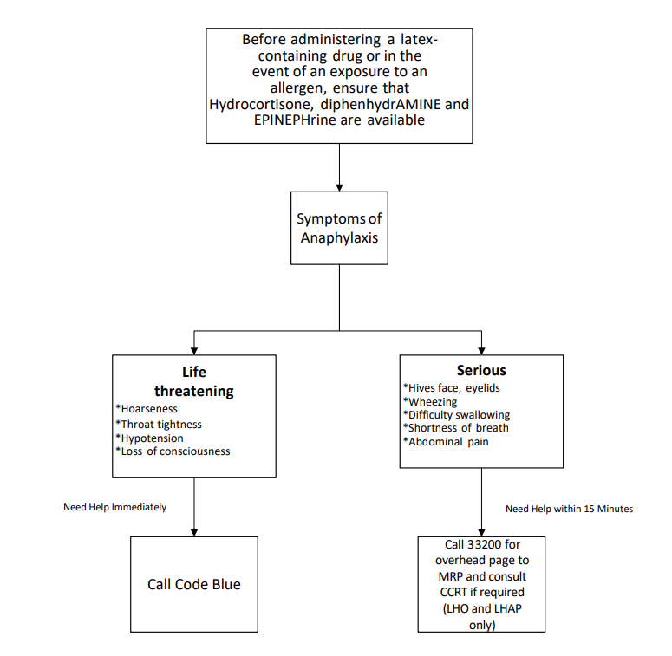

**Appendix B**

**Symptoms to Differentiate Types of Reactions**

|  |  |  |  |
| --- | --- | --- | --- |
|  | **TYPE I (IgE-mediated) IMMEDIATE HYPERSENSITIVITY** | **IRRITANT CONTACT DERMATITIS** | **ALLERGIC CONTACT DERMATITIS**  **(TYPE IV DELAYED HYPERSENSITIVITY)** |
| **Classification** | Hypersensitivity | Irritation | Allergic dermatitis |
| **Timing of onset** | Minutes to 1 hour | Minutes to hours | 1 to 3 days |
| **Description of sensation** | Flush, itching, tingling | Pain, burning, stinging | Itching first, then pain as skin breaks down |
| **Skin appearance** | Hives with blanched (white) centres; swollen; skin appears tight due to swelling | Redness, hard crusting, thickened skin, scabs, dry bumps, peeling; skin appears glazed or scalded | Redness, itching, scaling, peeling, swelling, fluid- filled blisters and oozing sores; skin appears dry, crusted, thickened |
| **Fissures (cracks)** | No fissures | Fissures | More sores than fissures |
| **Rate of healing (uncovered)** | Symptoms reduced within hours after allergen avoidance | Within 2 weeks after removal of source of irritation | May or may not diminish after allergen avoidance |
| **Margin of reaction** | Undefined margin, may be at point of contact or entire body | Sharp and well-defined | Undefined margin; may be at point of contact |
| **Tendency to spread** | Yes; may spread beyond contact area | No spread | Yes; may spread beyond contact area |
| **Respiratory involvement** | May have wheezing, runny nose, shortness of breath, chest tightness | None | None |
| **Facial involvement** | Swelling of eyelids, lips, face; tears, itchy eyes | Possibly, if face touched by irritant | Possibly, if face touched by the chemicals in the item to which the individual is allergic |
| **Systemic (total body) involvement** | Nausea, abdominal cramps, diarrhea, rapid heart rate, hives, shortness of breath, blood pressure drop, shock | None | None |
| **Type of contact** | Skin, mucous membrane, open wound, injection, inhalation of aerosol | Skin contact | Skin contact |
| **History of allergies** | Often | Not relevant; irritation can be present without allergic history | Often |

**Appendix C**

**Approach to Parenteral Drug Administration in a Latex Allergic Patient**

